Gairloch Museum Roundhouse Project
Archaeological Design Note for Tender Briefs
Build-related learning from the Achtercairn Roundhouse excavations
Prepared from Dr Tom Gardner’s presentation, Museum Talk: Achtercairn Roundhouse Excavation Findings, 4 May 2026, with additions from published comparative excavation reports at Culduthel and Black Loch of Myrton.
Purpose: to accompany craft and architectural tender briefs and support design-stage discussion.
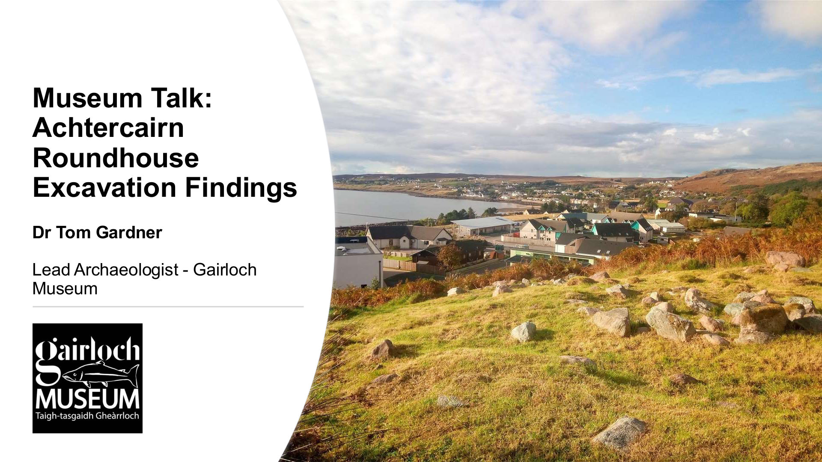
Figure 1. Dr Tom Gardner presentation title slide, showing Achtercairn and Gairloch Museum context. Source: HAF_Presentation_TG 1.pdf, slide 1.

Status of this note
This is a working archaeological design note, not a final excavation report or construction specification.

Contents
- 1. Immediate design messages for the tender pack
- 2. Landscape and settlement context
- 3. Roundhouse 10: main structural evidence
- 4. Roundhouse 8: comparative evidence
- 5. Comparable excavation evidence: Culduthel and Black Loch of Myrton
- 6. Evidence translated into design and craft questions
- 7. Craft-package notes
- 8. Interpretation and visitor-use implications
- 9. Post-excavation work and source list

1. Immediate design messages for the tender pack
The most important point for the tender briefs is that the reconstruction should be a practical interpretation of the Achtercairn evidence, not a generic Iron Age roundhouse. The excavations provide direct evidence for wall base, turf upper material, entrances, post settings, hearths, floor deposits, use-wear, activity areas and later reuse.
Design message | Why it matters
Use Roundhouse 10 as the main structural comparator, unless the design team formally decides otherwise. | RH10 has been excavated over three seasons, with overlapping trenches tied into one stratigraphic sequence. Around 40% of the internal space has been excavated and 25% removed down to the palaeosol, giving it the strongest direct evidence for a buildable reconstruction. RH8 is very useful for comparison, scale, entrances, walling and internal wear, but its phasing remains less resolved.
Represent a stone footing with turf upper walling. | RH10 produced an external stone footing and preserved individual turfs from wall tumble where sealed. The design should therefore avoid presenting the wall as a wholly drystone stone wall. It should make the stone/turf relationship visible and maintainable.
Treat the roof as needing an internal timber post-ring. | RH10 has an internal post-ring with repair phase, 15 pits/post-holes recorded in the 2022 trench, and floor deposits stacked up around posts in some cases. RH8 also produced post-holes with packing stones and/or post pads. The reconstruction should explore how a timber frame/post-ring works with turf and stone walling.
Use the entrance evidence explicitly. | RH10 has an entrance facing directly west down Loch Gairloch, indicated by a gap in the wall line, disturbance of the floor surface at the threshold and double post-holes for lintel support. RH8 has a south-west facing entrance with a spill of tumbled stone downhill. If the Museum reconstruction cannot follow this orientation exactly because of access or planning constraints, the reason should be recorded and interpreted.
Do not design a clean, empty interior. | Both excavated roundhouses show domestic use, worn floors, hearths, post settings and activity areas. RH10 has a central hearth with stake-holes, a cobbled activity area, drainage features, burnt bone, potboilers, hammer stones, rubbing stones and pottery fragments. These features should inform the interior, floor, handling materials and interpretation.
Build in maintenance and repair as an archaeological theme. | RH10 appears to have an internal post-ring with a repair phase and floor deposits built up around posts. RH8 shows wear in the palaeosol and post-holes with packing or pads. The reconstructed building should show that roundhouses were maintained, repaired and adapted over time.
Design the floor as a working, wearing surface. | RH10 had organic and spongy floor deposits, erosion features and a cobbled activity area around the hearth. RH8 had soft organic-rich infill in worn hollows in the palaeosol and a measurable dip of about 120mm within the house, interpreted as significant internal wear. A modern public floor must be safe and accessible, but should still communicate a layered, worn and maintained surface.
Keep the uncertainties visible. | The post-excavation programme is still ongoing. The poorly-fired clay feature, turf blocks, phasing of RH8 and some activity areas should be described as evidence under investigation. This is helpful for interpretation and protects the project from overclaiming.

2. Landscape and settlement context
Achtercairn is part of a wider prehistoric domestic landscape around Loch Gairloch. The presentation places the excavated structures within a group of possible roundhouses first well-surveyed by the WeDigs project in 2010-2012. The roundhouses are linked by a well-maintained community path system with an accompanying guide by Jeremy Fenton. The wider landscape also includes post-medieval settlement, shielings, a Bronze Age round cairn, prehistoric field systems and other sites, not all of which are as fully surveyed as the roundhouses.
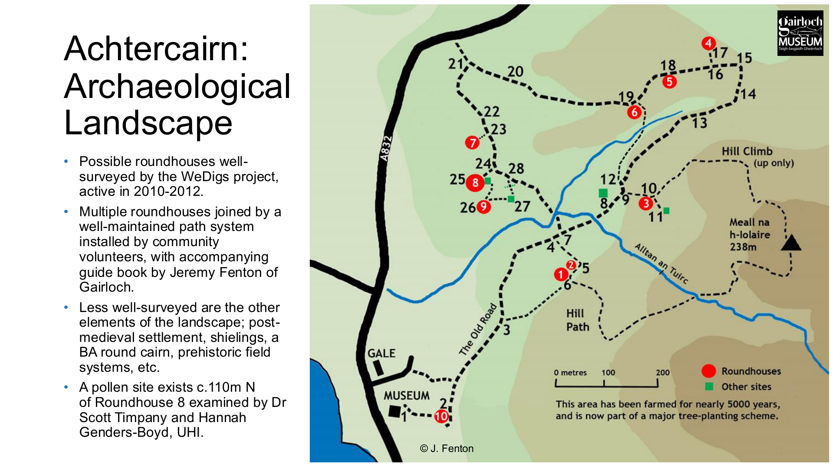
Figure 2. Achtercairn archaeological landscape, showing roundhouses, paths and other sites. Source: Gardner presentation, slide 5; map © J. Fenton.
Environmental evidence is important for materials and interpretation. The pollen evidence from the Achtercairn 3 core, around 110m north of Roundhouse 8, points to continuity of settlement in the landscape rather than total abandonment. The pollen sequence preserves Neolithic and Bronze Age evidence, although no Iron Age record survived in that core. It suggests an early landscape of scrub woodland, grassland and heath, followed by an abrupt move towards heath and grassland after woodland decline. Cereal pollen and high microscopic charcoal values imply deliberate clearance for arable activity, while macroscopic charcoal suggests felled wood was used for fuel. Non-pollen palynomorph evidence, including dung-related fungi and animal hairs, indicates livestock. This matters because the reconstructed roundhouse should sit within a story of cleared woodland, fuel use, grazing, cultivation, heather, turf, timber and ongoing landscape management.

3. Roundhouse 10: main structural evidence
Roundhouse 10 is the most useful excavated structure for design-stage reconstruction thinking. It sits just behind the Museum and appeared before excavation as a low ring of turf-covered stone surrounding a central platform cut into the slope. Two later shielings sit on the site. Excavations took place across 2020, 2021 and 2022, using overlapping trenches that could be tied together stratigraphically. The work identified a well-preserved but partially eroded roundhouse with strong evidence for stone footing, turf wall material, internal posts, hearth, activity areas, floor deposits and later disturbance.
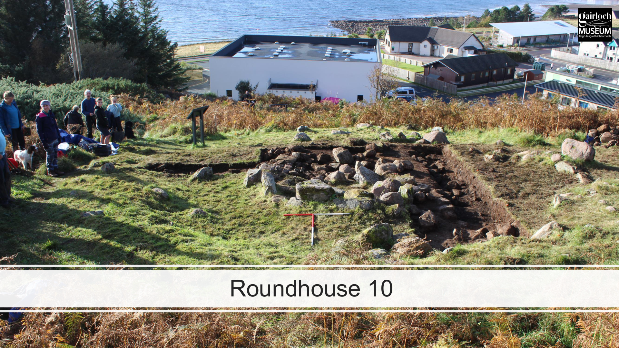
Figure 3. Roundhouse 10 during excavation, overlooking the Museum and Loch Gairloch. Source: Gardner presentation, slide 7.

3.1 Excavation sequence and reliability of the evidence
- 2020: an L-shaped trench was used under Covid restrictions. It identified the external stone footing of the roundhouse wall, preserved individual turfs from the tumble of the wall, and good preservation of material sealed beneath wall collapse. A possible destruction deposit was recorded across the site.
- 2021: a larger box trench extended over the 2020 footprint. Excavation went through the possible destruction deposit onto the roundhouse floor, identifying negative features and activity areas. A separate trench was opened to test for an entrance in the south-east, but the entrance evidence instead indicated an opening facing directly west, down Loch Gairloch.
- 2022: a further extensive trench, partly overlapping 2021, exposed a larger area of floor and internal features. The west half of Shieling 1 was excavated and reinstated. Combining 2020, 2021 and 2022 data produced contiguous north-south and east-west sections.
- All three seasons reached the same stratigraphic horizon and had overlaps that allowed the data to be tied together. Around 40% of the internal space was excavated, with 25% removed down to the palaeosol below. Auger data from outside the roundhouse contributed to a consistent sequence spanning more than 140 contexts.
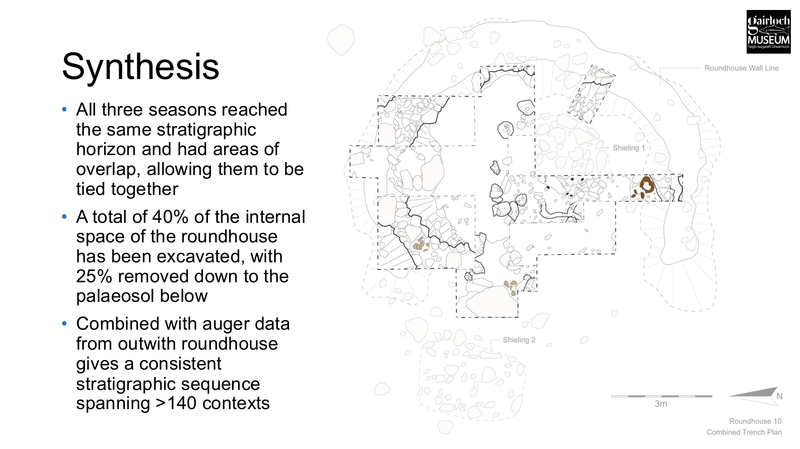
Figure 4. Combined RH10 trench plan and synthesis, showing the extent of excavated areas and the roundhouse wall line. Source: Gardner presentation, slide 13.

3.2 Wall construction: stone footing and turf upper
Evidence: RH10 had an external stone footing to the roundhouse wall and preserved individual turfs from the tumble of the wall, especially where sealed by later material. The presentation synthesis describes the structure as having a stone footing with a turf upper, with turves surviving where sealed.
Design implication: The wall should not be treated as a purely drystone circular wall. A plausible Achtercairn reconstruction needs a stone base/footing with turf forming at least part of the upper wall, wall mass or cap. The exact profile, height and structural role of the turf element remain design questions. The wall design should allow the craft team to demonstrate how turf behaves as a building material, how it is cut and laid, how water is shed, and how edges are protected.

3.3 Internal post-ring and repair
Evidence: RH10 produced an internal post-ring with a repair phase. In 2022, 15 pits/post-holes were recorded with floor deposits visible stacked up around posts in some cases. A double post-hole around 1.5m from another double post-hole identified in 2021 lay on the western wall line. The entrance evidence also included paired post-holes interpreted as lintel support.
Design implication: The roof should be developed around a timber structure that can be read inside the roundhouse. The evidence supports a structural post-ring and repairs or replacement over time. Could we avoid a perfectly regular modern circle if the archaeological evidence suggests maintenance, repair and adaptation?

3.4 Entrance and threshold
Evidence: The 2021 trench identified the entrance facing directly west, down Loch Gairloch. This interpretation was based on a gap in the wall line, disturbance of the floor surface at the threshold, and a double post-hole for lintel support on the wall line.
Design implication: Entrance orientation should be treated as archaeological evidence. A west-facing entrance would connect the reconstructed structure with the loch view and the excavated RH10 evidence.
Craft implications: The threshold should be designed as a high-wear area, likely requiring hardening, drainage and repair. The paired/lintel support evidence gives the timber craftsperson a specific element to develop, perhaps with a robust door frame that is also interpreted as part of the archaeological translation.

3.5 Hearth, stake-holes and fire-related activity
Evidence: RH10 had a central hearth-stone with five surrounding stake-holes. There were drainage features to the west of the hearth, a cobbled activity area around the hearth, seven fragments of burnt bone from the working surface, and extensive potboilers. This supports a domestic, fire-centred interior.
Design implication: The hearth should be a central interpretive and design feature. The project needs to decide whether it will support occasional real fire, demonstration fire only, symbolic hearth use, or no fire. This decision affects ventilation, smoke staining, fire safety, insurance, floor material, visitor capacity, thatch maintenance, and the building warrant. Even if real fire use is limited, the hearth area should be designed as a working surface with associated activities, rather than as a decorative circle of stones.

3.6 Floors, wear and internal surfaces
Evidence: RH10 had organic and spongy floor deposits, activity areas on the floor surface and erosional features showing wear during use. The best preservation occurred under sealing material, either later shielings or roundhouse wall collapse. Floor deposits were seen stacked up around posts in some cases. The 2022 plan separates activity areas, pits/post-holes, linear cuts, a fired clay feature, intact turfs and stake-holes.
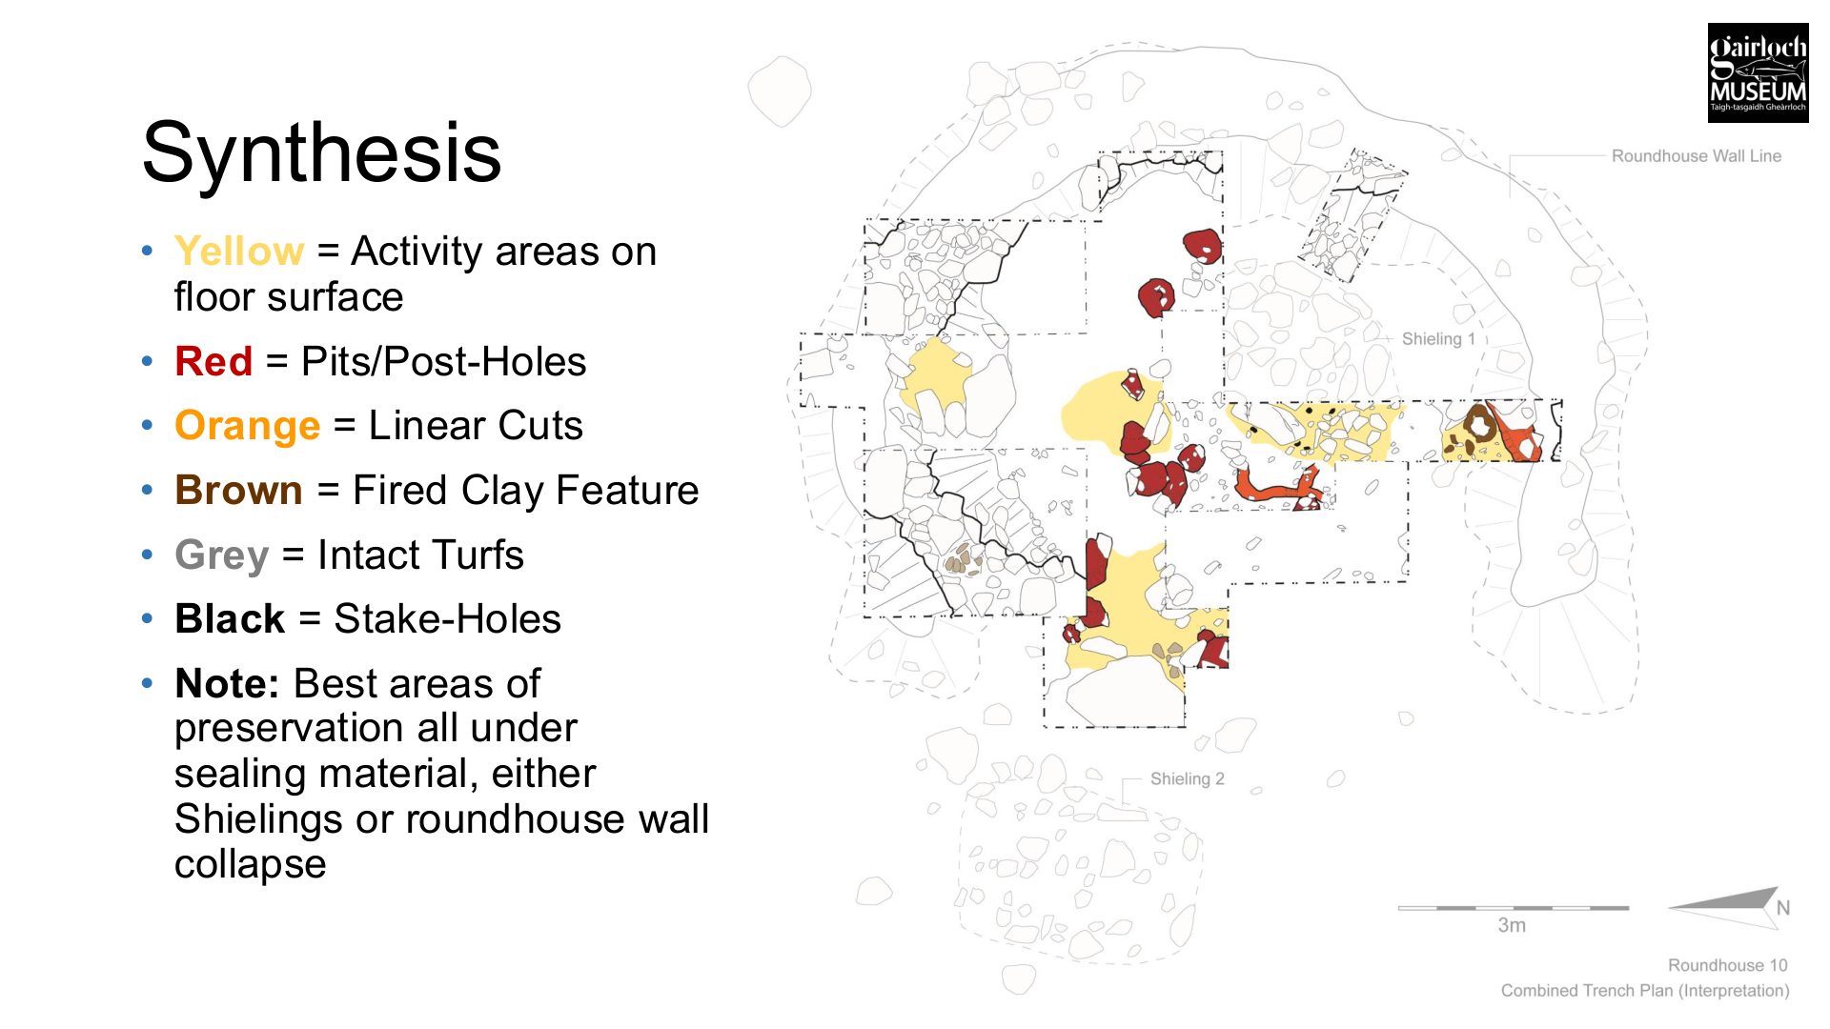
Figure 5. RH10 synthesis plan, distinguishing activity areas, pits/post-holes, linear cuts, fired clay, intact turfs and stake-holes. Source: Gardner presentation, slide 14.
Design implication: The reconstruction should include variation: a hard-wearing threshold, a robust hearth/working area, possible stone or compacted surfaces in high-use zones, and interpreted organic floor material in selected areas. For public use, the whole floor must be safe, cleanable and accessible, but the design can still show how an Iron Age interior was worn, patched and maintained.

3.7 Poorly-fired clay feature
Evidence: A poorly-fired clay feature with a stone base was identified, quarter-sectioned, block-lifted and sampled for soil micromorphology. Its function is not yet resolved from the presentation evidence.
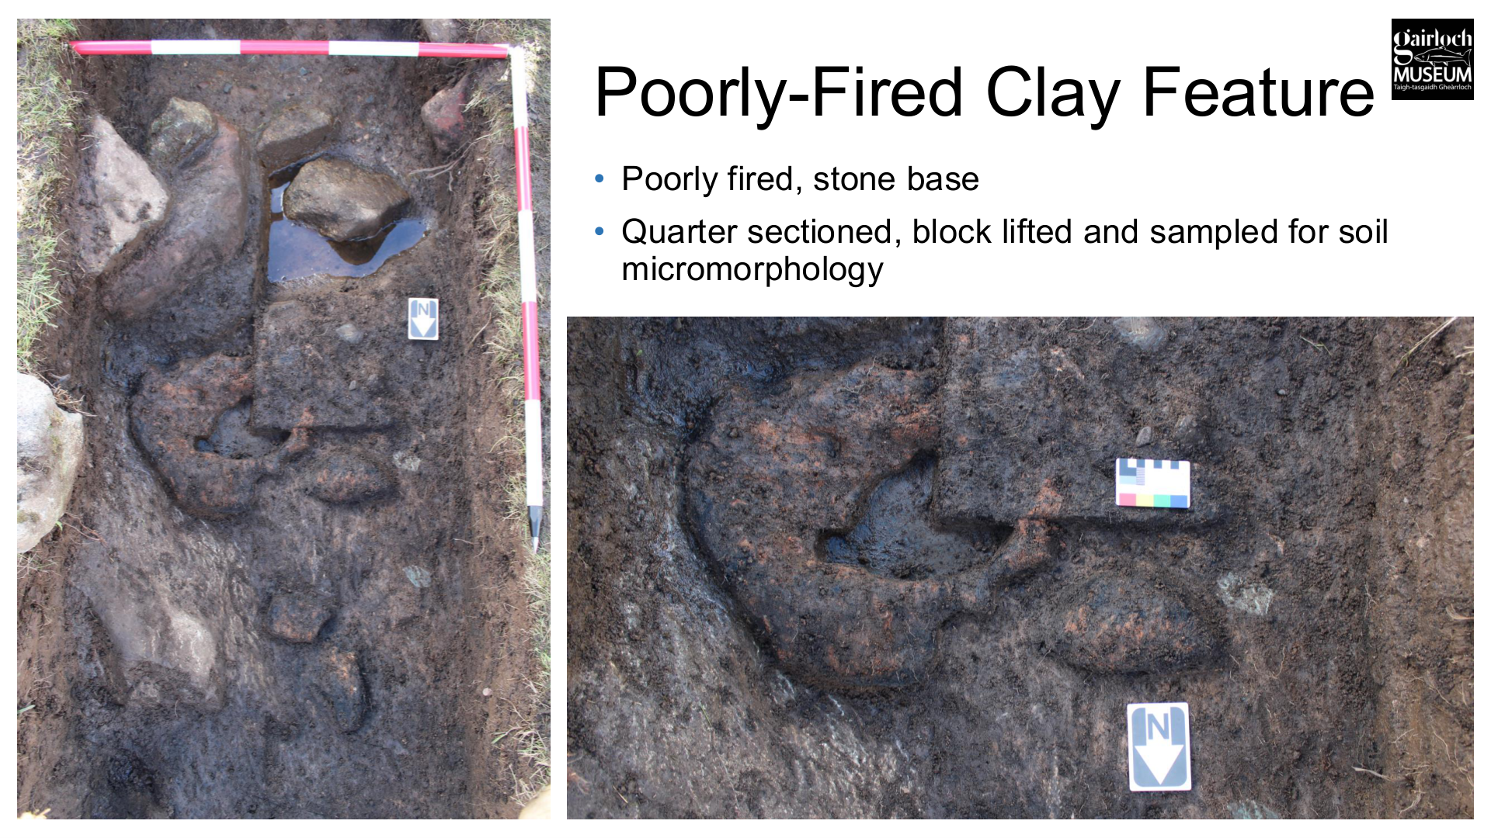
Figure 6. Poorly-fired clay feature with stone base, sampled for micromorphology. Source: Gardner presentation, slide 19.
Design implication: This should not be reconstructed as a definite object until post-excavation analysis clarifies its formation and function. It is, however, a good feature for interpretation because it shows how archaeological evidence can be ambiguous and how microscopic analysis contributes to reconstruction decisions.

3.8 Material culture and domestic activity
Evidence: RH10 produced two ceramic fragments from secure contexts: one from a post-hole within the internal post-ring and one from an occupation deposit. Seven small fragments of burnt bone came from the working surface around the hearth. A total of 78.824kg of potboilers was recorded. The assemblage also included 18 hammer stones and 14 rubbing stones.
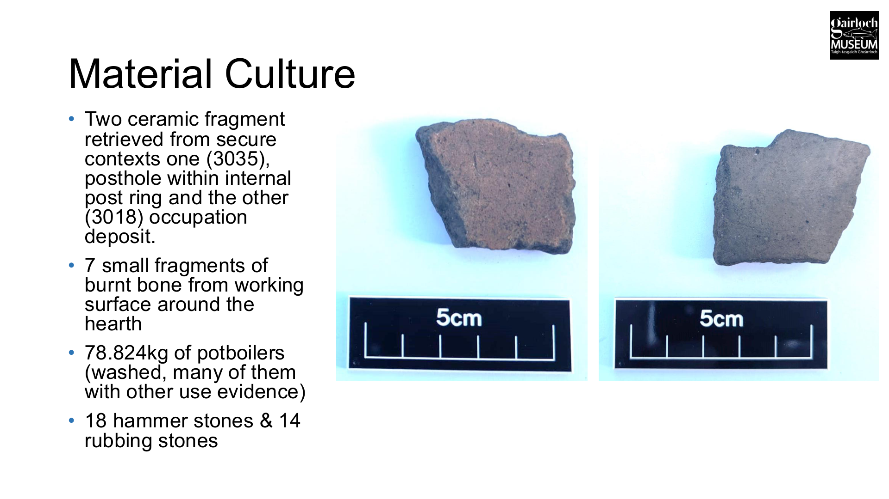
Figure 7. RH10 material culture slide, including ceramic fragments and figures for potboilers, hammer stones and rubbing stones. Source: Gardner presentation, slide 20.
Design implication: The reconstructed roundhouse should communicate cooking, heating, food processing, tool use and repair. Handling materials, potboilers, hammer/rubbing stones and a clear hearth-work zone.

4. Roundhouse 8: comparative evidence
Roundhouse 8 is important because it shows the range and complexity of the Achtercairn group, but it should be used carefully in design. It is the largest structure in the group and has previously been interpreted in several different ways, including as a stone circle or ceremonial site, proto-broch or roundhouse. The 2025 excavation appears to rule out the stone circle/proto-broch interpretations, but questions remain about phasing.
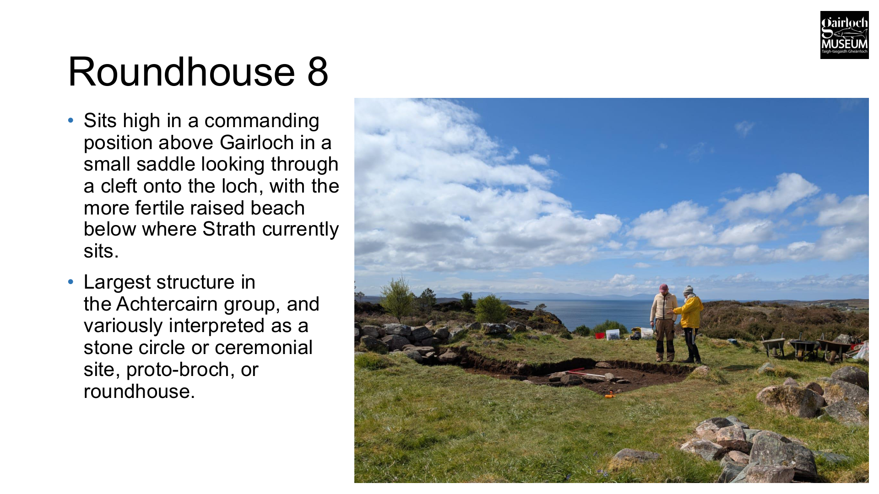
Figure 8. Roundhouse 8 context slide: high saddle position, view to the loch and interpretive uncertainty before excavation. Source: Gardner presentation, slide 22.

4.1 Scale, wall and entrance
- RH8 sits high above Gairloch in a small saddle, looking through a cleft onto the loch, with more fertile raised beach below where Strath now sits.
- It has a large internal diameter of around 11.5m, delineated by a large tumbled stone wall.
- Areas of wall facing were visible, but only as a single course and formed of large erratics.
- The entrance faces south-west, with a significant spill of tumbled stone downhill in that direction.
- A shieling again sits inside the roundhouse, showing later reuse and potential sealing/disturbance.
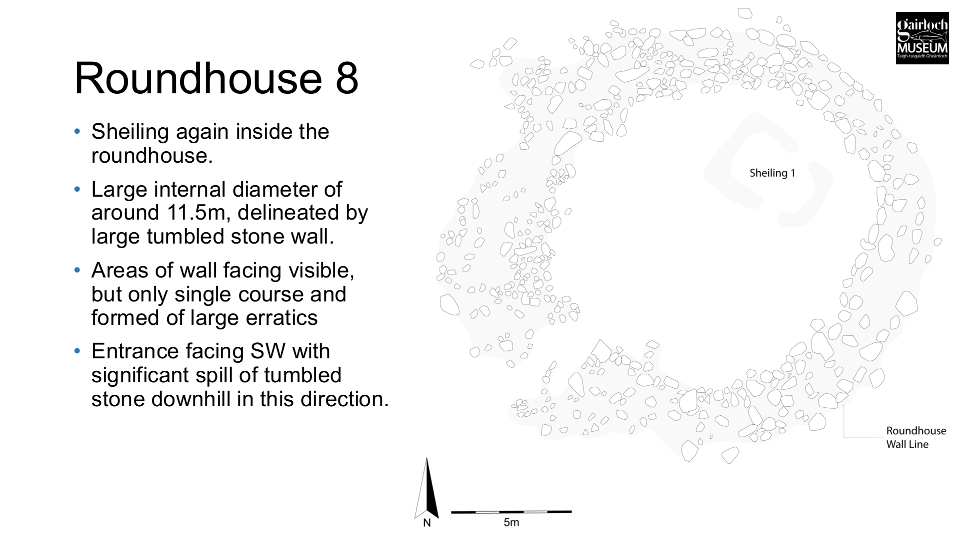
Figure 9. RH8 wall and entrance evidence: large internal diameter, single-course facing of erratics, SW entrance and tumbled stone. Source: Gardner presentation, slide 23.
Design implication: RH8 shows that local roundhouses were not all the same size or form. Its 11.5m internal diameter is much larger than the currently discussed Museum reconstruction scale, so RH8 should be treated as comparative evidence rather than the direct model for the planned building. It also confirms that south-west/west-facing entrances are plausible within the local group.

4.2 Hearths, post-holes and worn interior
- The trench across the centre and south wall aimed to connect a WeDigs hearth feature with internal deposits and the wall, in order to tie the dated hearth into the structure stratigraphically.
- The excavation encountered a second off-centre hearth, well-preserved occupation deposits and multiple negative features.
- Eleven post-holes and one large pit were identified. Post-holes varied in size and had packing stones and/or post pads in place.
- Occupation deposits were mainly soft, organic-rich infill of worn hollows in the palaeosol below the structure, with hearth debris around both hearths.
- The base of the wall sat on the palaeosol, which dived steeply by around 120mm within the roundhouse. This was interpreted as evidence of significant internal wear.
- The two hearths could be tied stratigraphically because both were cut into the palaeosol, with occupation deposits directly superimposed onto them.
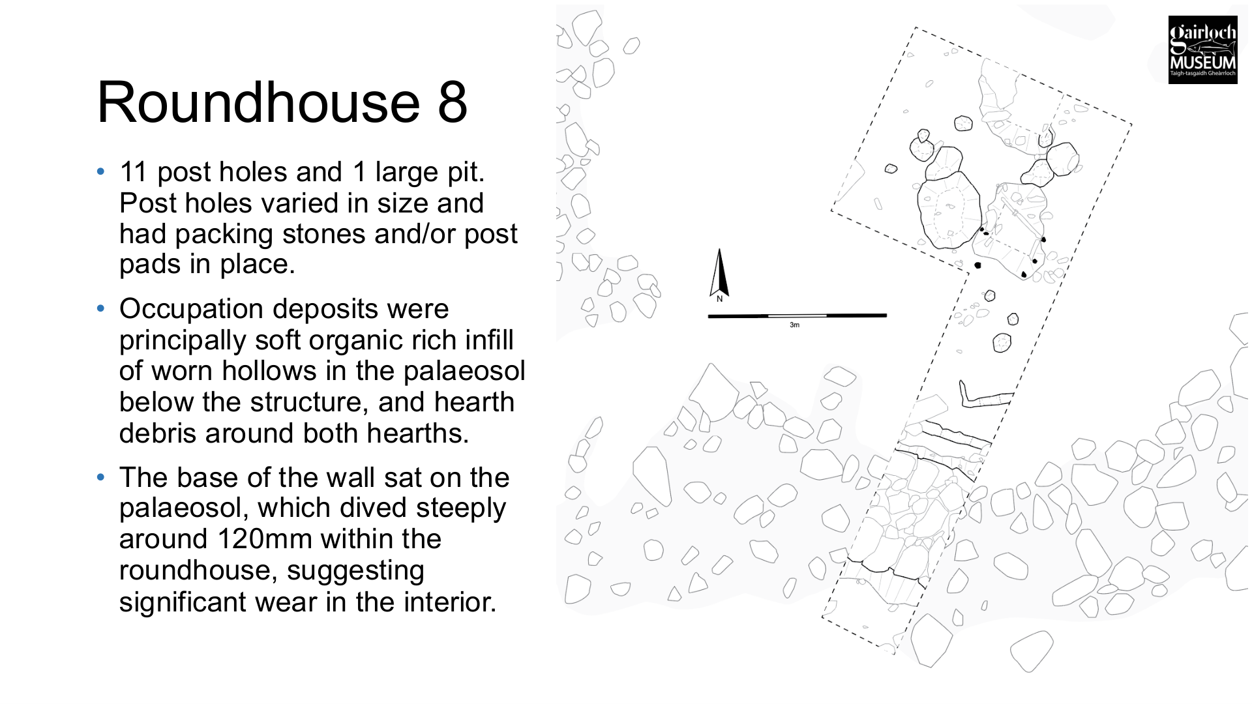
Figure 10. RH8 evidence for post-holes, post pads/packing, organic-rich worn hollows and 120mm internal wear in the palaeosol. Source: Gardner presentation, slide 25.
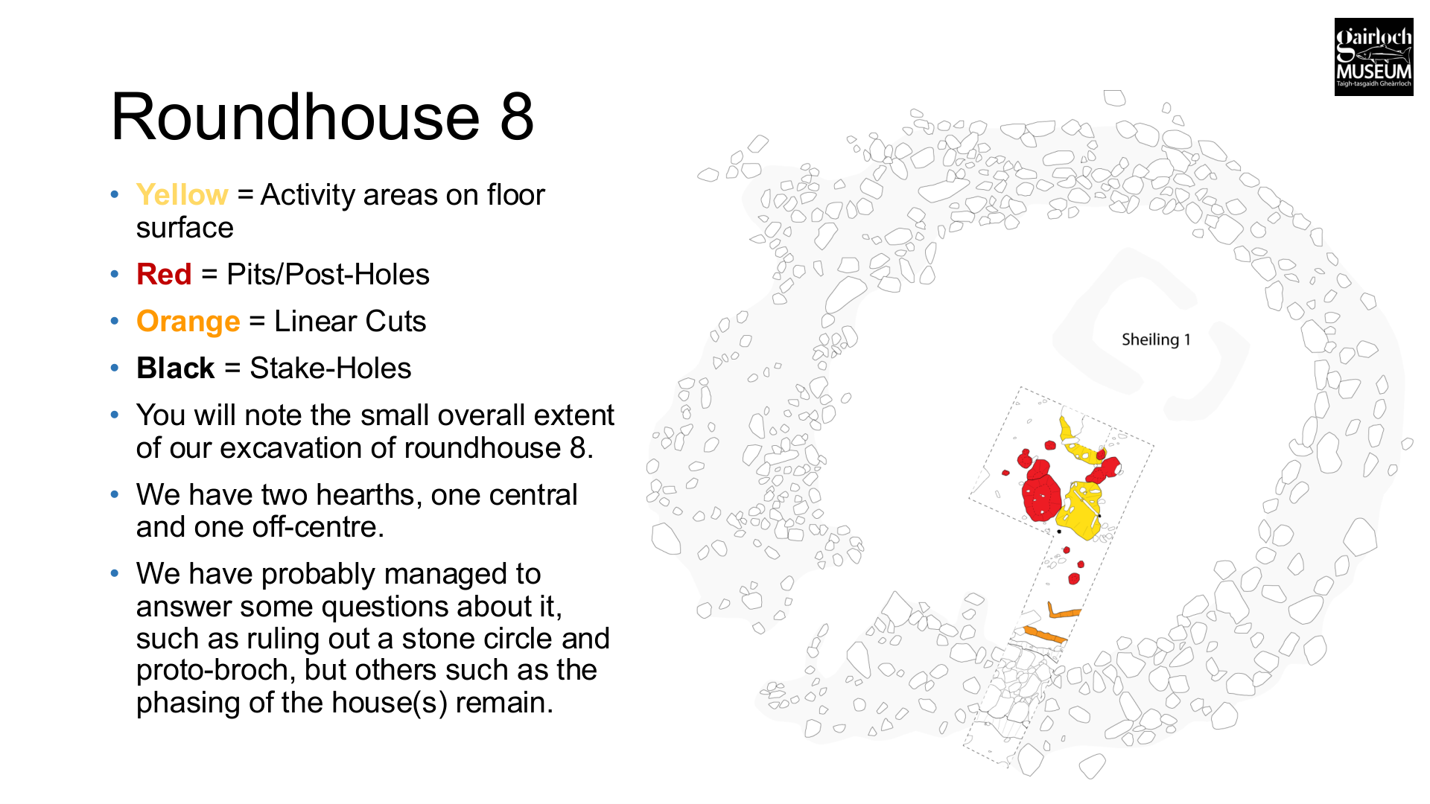
Figure 11. RH8 synthesis slide, showing activity areas, pits/post-holes, linear cuts, stake-holes and the two hearths. Source: Gardner presentation, slide 27.
Design implication: RH8 reinforces the need to design the floor as a worn, changing surface. It also supports the use of packing stones and/or post pads as a practical and archaeologically visible detail for posts. The two hearths should not be copied into the Museum reconstruction, but they should inform interpretation: roundhouse interiors were reworked, re-used, re-built, or organised differently over time.

4.3 RH8 material culture
Evidence: RH8 produced potboilers, though apparently in a less significant concentration than RH10, assorted hammerstones and grinding stones, three ceramic fragments which at first look were likely Iron Age and from different vessels, and a flint polyconcave blade from a large pit. The flint blade is likely Early Neolithic and may be residual or represent the long time-depth of activity in the landscape.
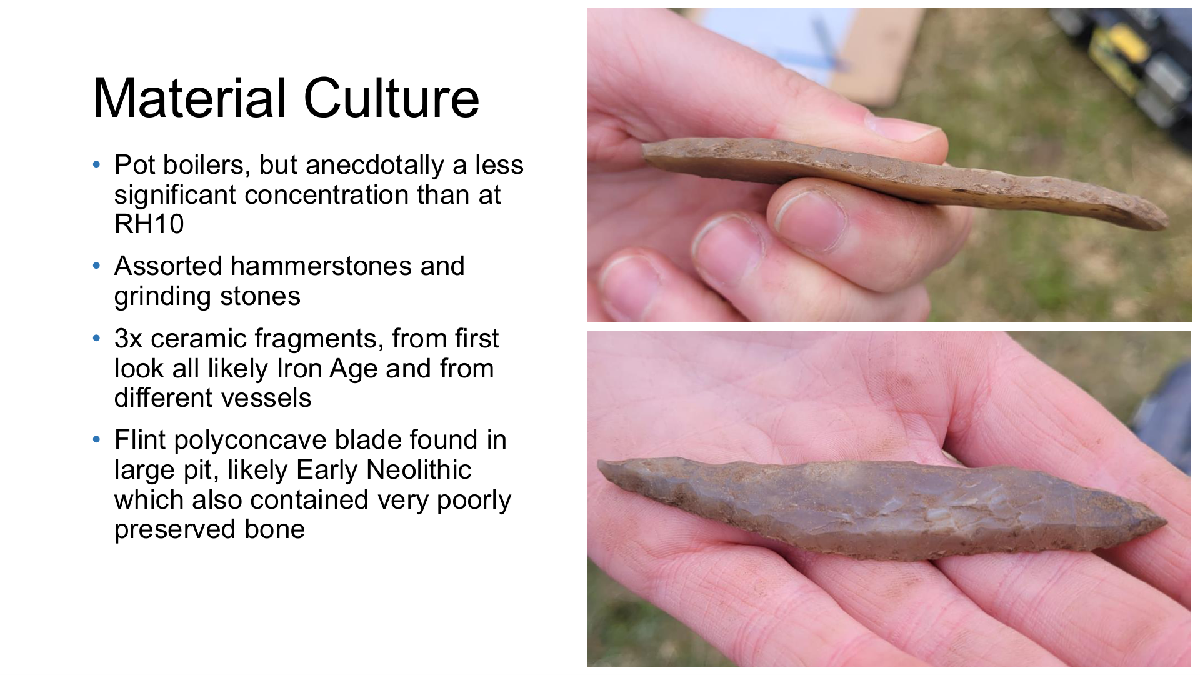
Figure 12. RH8 material culture summary. Source: Gardner presentation, slide 33.

5. Comparable excavation evidence: Culduthel and Black Loch of Myrton
The Museum reconstruction should be led by the Achtercairn evidence, especially RH10 and RH8. However, some construction questions cannot be answered from Achtercairn alone. The comparable excavation reports below provide an academic evidence base for plausible wall, turf, timber and jointing choices.

5.1 Why they are useful for this project
- Achtercairn gives the local plan form, setting, wall survival, floor evidence, entrance evidence, hearth evidence and material culture context.
- Culduthel gives useful excavated parallels for turf, stone-and-turf and turf-and-earth walling in Iron Age Scotland, including cases where turf walling is recognised through collapsed or burnt deposits rather than surviving blocks.
- Black Loch of Myrton gives exceptional preserved timber and organic evidence, including post-rings, plank walling, wattled walls, thresholds, post bases, mortises, pegs, tow-holes and toolmarks. It is particularly useful for discussing how roundhouse timber elements were selected, worked, joined and repaired.
- Both sites are different from Gairloch. Culduthel was a major craftworking centre near Inverness, and Black Loch of Myrton was a wetland settlement in south-west Scotland. Their value here is in construction detail, material behaviour and interpretation of missing organic evidence.

5.2 Culduthel: turf and stone-and-turf wall evidence
Culduthel should be used as a turf-wall comparator because it preserves several ways in which turf or turf-and-stone architecture may appear archaeologically: as a possible turf outer wall held by timber revetting; as stone foundations for probable turf walling; as a later external stone-and-turf apron wall; and as burnt or collapsed turf deposits over timber. This is directly relevant to the Gairloch question of how a stone footing, turf wall, timber structure and eaves might have worked together.

House 5: turf wall with timber revetting
- House 5 was a large Early Iron Age roundhouse where only the internal post-ring survived clearly, with a curved line of posts and small post-/stake-holes defining the outer wall.
- The excavators suggest the outer wall may have been turf, with the line of stakes and larger posts forming a timber revetting around the outside edge of the wall.
- The report notes wider parallels for turf-and-earth or ring-bank roundhouses, including examples where wattle and post revetting were recognised on the inner and outer faces of the wall. This is useful for Gairloch because it shows that a turf wall need not be a free-standing block mass; it may be held, faced or constrained by timber elements.
Design relevance: the Gairloch wall could reasonably be explored as a stone-footed or stone-based wall with a turf superstructure that is stabilised by stakes, wattle, timber pins or other retaining details.

Workshop 11: flat stone base and collapsed turves
- Workshop 11 was an irregular U-shaped turf-and-stone structure associated with glass and copper-alloy working.
- Two curving arrangements of flat stones formed foundations for a probable turf wall. One surviving wall base was about 2m long and 0.6m wide; another curving length of flat stones formed a base up to 1.48m wide.
- A compact light-yellow sandy silt layer over the stones was interpreted as collapsed turves. The wall bases had been built onto a compact sandy layer that contained charcoal, burnt clay, slag and artefactual material.
Design relevance: Culduthel supports the idea that a turf wall can have a stone base or foundation course.

House 10/3: external stone-and-turf apron wall and remodelled entrance
- In its final phase, Culduthel House 10/3 became a large ring-groove roundhouse with paving, an external apron wall of turf and stone, and an elaborate porch.
- The Stage 1 outer wall was defined by a narrow ring-groove up to 0.65m wide and 0.6m deep, with closely set posts around 0.2m in diameter held with stone packing. Stake-holes around the outside of the ring-groove suggest an external wattle or fence element abutting the wall.
- At Stage 2, a single-course rubble line was built to follow the curve of the ring-groove. It was interpreted as the base for a turf-and-stone wall encircling the house parallel to the outer timber wall.
- The stone-and-turf wall was a later remodelling rather than part of the initial design. It was built directly onto the cobbled yard, widened towards the entrance, may have encompassed or flared around the porch, and created a more substantial external appearance.
Design relevance: this is useful for the Gairloch entrance and wall discussion. A turf-and-stone wall can be an outer skin or apron that changes the appearance and performance of an existing timber wall. It can make the entrance longer, more protected and more imposing. Is our wall the primary wall, a footing for the roof, an outer protective apron, or a combination?

Culduthel questions for our turf design
- What will our wall section actually be: stone base with turf upper, turf wall on stone footing?
- Is the turf intended to carry load, retain weather, insulate, give wall mass?
- Should the turf wall have an inner or outer revetting system of stakes, wattle, timber pins or stone facing? If so, which parts are archaeologically visible?
- How will turf blocks be cut, laid and recorded? Until the Achtercairn micromorphology is available, the design should avoid fixing a precise turf thickness or laying pattern as if it were proven locally.
- How will the interface between stone and turf shed water?

5.3 Black Loch of Myrton: timber, joints and organic construction evidence
Black Loch of Myrton is especially useful because waterlogged conditions preserved the organic parts of roundhouses that usually disappear on dryland sites. It should be used to help the timber craftsperson, architect and engineer discuss timber species, post bases, wall construction, entrance assemblies, joints, pegs, wattle, toolmarks and the labour involved in timber preparation. The Gairloch reconstruction can use Black Loch to make visible the kinds of timber decisions that may once have existed at Achtercairn but are no longer preserved.

Wood selection by function
- In ST2, alder was used mainly for large horizontal components: foundation framework, radial floor components, sillbeams and entrance structure.
- Oak was used mainly for major vertical or high-wear elements: outer post-ring posts, vertical outer-wall planks and entrance posts. The inner post-ring used a mixture of oak and alder.
- Hazel and alder were the main wickerwork materials. Hazel dominated many stake-lines and withies, while willow was also important in some trackside fences.
- ST3 used much smaller timbers and very little oak. Its outer walls were stake-built, presumably woven with wickerwork, and the surviving post-ring posts were alder and ash. This shows that Iron Age timber construction could vary within one settlement, depending on date, scale, access to timber and the perceived importance of the building.
Design relevance: the Gairloch timber specification does not need to use one timber species throughout. A more archaeologically interesting approach is to select species by function, availability and durability.

Post-rings and post bases
- At Black Loch, the most complete post-ring evidence came from ST2. Some post-ring posts had concave bases, designed to sit over roundwood radials of the sub-floor structure.
- The report interprets this as a way of spreading the compressive load of the ring-beam and roof in a soft substrate. Pencil-tipped posts were used where posts needed to anchor parts of the superstructure into the foundation framework. Flat-based posts were used where load-bearing was not the main requirement or where posts were held in mortise holes.

Thresholds, mortises and entrance carpentry
- The Black Loch trackway and ST2 entrance preserved large threshold timbers and complex carpentry. Oak threshold beams had open mortises at their ends for vertical posts and stepped chamfers along their axes, probably linked to gates or doors.
- The ST2 entrance used substantial sleeper beams with squared mortises cut through the timber, aligned with plank-built walls and posts. The report describes this as some of the most sophisticated carpentry on the site.
- Mortises, notches, pegs, possible plank slots and replaceable threshold elements all show that the entrance was a major focus of woodworking skill and repair.
Design relevance: the Gairloch entrance could be the best place to show craft detail. The paired post evidence at RH10 already makes the entrance structurally important. Black Loch supports treating the threshold, door, lintel/portal frame and pegged joints as a visible learning feature.

Toolmarks and volunteer learning
- Much timber at Black Loch was used as undressed roundwood, while more complex conversion was used where needed: tangentially split oak planks, shaped post bases, tow-holes, mortises, pegs, dowel holes and pared surfaces.
- Toolmark analysis identified axes/adzes, chisels and gouges. Many posts retained bark, but selected pieces were stripped, shaped or dressed for function or appearance.
- Tow-holes in large logs and planks are useful evidence for how heavy timbers were moved and handled.
Design relevance: this creates strong volunteer and interpretation opportunities. The build can include debarking, peg-making, cleaving, shaving, sample joints, toolmark recording and demonstration of how heavy timbers are moved.

Black Loch questions for the Gairloch timber design
- Which parts of the Gairloch build should be simple roundwood, and which justify more complex carpentry such as mortise joints, pegs, plank cheeks or framed thresholds?
- Can the entrance be designed as the main place where visitors see high-quality jointing and timber craft, while the rest of the building remains more materially simple?

6. Evidence translated into design and craft questions
The following table translates the archaeological evidence into practical questions for the architect, structural engineer and craft team. It is intended for use during Stage 1 design input and should be reviewed in the design meeting with Dr Tom Gardner, the architect and the relevant craftspeople.
Topic | Archaeological evidence | Design / craft question
Overall model | RH10 provides the strongest structural evidence; RH8 provides comparative scale and variability. | Confirm that the Museum reconstruction is primarily informed by RH10, with RH8 used as comparative evidence. Record where design diverges from archaeological evidence for access, safety or planning reasons.
Wall base | RH10 external stone footing; RH8 large tumbled stone wall with single-course facing of large erratics. | Decide stone sourcing, wall width, stone size, facing/core approach, and how much archaeological character can be retained while meeting stability and visitor safety requirements.
Turf upper wall | RH10 preserved individual turfs under wall tumble; synthesis states stone footing with turf upper. | Define turf wall/cap profile, turf thickness, orientation, laying method, edge protection, watering/establishment and repair strategy.
Roof support | RH10 internal post-ring with repair phase; RH8 post-holes with packing stones/post pads. | Develop timber frame/post-ring with structural engineer.
Entrance | RH10 west-facing entrance down Loch Gairloch; RH8 south-west entrance with tumbled stone spill downhill. | Choose orientation based on archaeology, access, prevailing weather, visitor flow and planning. If a practical orientation differs from RH10/RH8, record this clearly.
Threshold | RH10 threshold disturbance and lintel-support post-holes. | Design a robust threshold with drainage, wear resistance, accessibility and interpretive link to lintel/post evidence.
Hearth | RH10 central hearth-stone with five stake-holes; RH8 central and off-centre hearths. | Decide live fire status, ventilation, smoke management, fire safety, floor material and staff/volunteer procedures. Do not treat hearth as merely decorative.
Floor | Organic and spongy deposits, worn hollows, erosional features, cobbled activity area, floor build-up around posts. | Create a safe public floor that still communicates worn, layered, maintained surfaces. Consider different zones rather than one uniform floor.
Drainage | RH10 drainage features west of hearth; slope/platform context. | Use discreet drainage and floor falls. Avoid water collecting against turf, posts, thatch junction or hearth. Make drainage part of build interpretation where possible.
Activity areas | RH10 activity areas, potboilers, burnt bone, hammer stones, rubbing stones, ceramics. | Interior should support cooking, processing and repair interpretation. Include handling objects or replicas
Uncertain features | Poorly-fired clay feature sampled for micromorphology; possible demolition deposit/agricultural soil. | Do not over-reconstruct uncertain features. Include them as interpretation of archaeological method and uncertainty.
Later reuse | Shielings inside RH10 and RH8; preservation under later deposits. | Interpret the sites as long-lived places with reuse, not single-period ruins.
Maintenance | Post repairs, floor wear point to maintenance over time. | Include repair in design.

7. Craft-package notes

7.1 Stone / drystone / walling
- Start from RH10: stone footing with turf upper, rather than a wholly stone wall.
- Use RH8 as evidence for large erratics, single-course visible facing in places, and tumbled stone. Weathered, field-cleared or locally characteristic stone will be more convincing than fresh quarried stone if supply and safety allow.
- Decide whether the wall is load-bearing, partly load-bearing, or mainly a footing/retaining mass for turf with the roof carried by posts. This decision must be made with the structural engineer and timber lead.
- Plan wall drainage and avoid trapping water against turf or timber. RH10 drainage features near the hearth and the sloping site context make water management a design issue.
- Threshold and entrance stonework should be robust. The RH10 threshold evidence and RH8 downhill stone spill should inform this detail.
- Stone sorting should include facing stones, packing/infill, threshold stones, hearth/working stones and possible post-packing/post-pad stones.

7.2 Turf
- RH10 gives direct evidence for turf in the wall structure: individual turfs survived in wall tumble where sealed.
- Turf should be specified as a construction material with maintenance requirements.
- Design needs to decide turf profile, laying pattern, thickness, rooting direction, establishment period, edge protection, anchoring and repair method.
- If a turf cap or upper wall is used, ensure it can be inspected and repaired by trained volunteers or contractors without dismantling unrelated fabric.
- Turf sourcing, cutting and storage should be planned early. The turf should be cut close enough to use to avoid drying out, but the programme also needs contingency for weather and access.
- Interpretation should explain why turf survived archaeologically only where sealed, and why absence elsewhere does not mean it was not present.
- Use Culduthel as a practical comparator for how turf may have worked with stone and timber: turf mass over or beside stone bases, possible timber/stake revetting, and collapsed or burnt turf identifiable as sandy/orange/brown deposits.
- Do not fix a final turf block size, orientation or laying pattern until the micromorphology results are available.
- The wall/eaves junction is important. Turf must be protected from water running off the roof, and the stone/turf interface must be inspectable because it is likely to be a high-weathering point.
- Record the turf build process for future research: source location, vegetation type, rooting depth, cut dimensions, stacking method, orientation in wall, bedding layers, fixings and repair method.

7.3 Timber / greenwood / structural roof
- RH10 has an internal post-ring with a repair phase; RH8 has post-holes with packing stones and/or post pads. The timber frame should therefore be a visible design driver.
- The timber lead should advise on post setting, packing, and how to reconcile archaeological plausibility with building warrant expectations.
- Entrance/lintel support should respond to RH10 paired post-hole evidence on the wall line.
- Timber choice should be discussed against local availability, durability, interpretation, maintenance, and structural need. Record decisions.
- The final design should avoid making the interior look artificially perfect. A controlled degree of irregularity, and repair may communicate the archaeology better than a clean architectural frame.
- The timber craftsperson should contribute to the maintenance manual, especially inspection of post bases, joints, roof timbers, smoke effects, moisture and repair/replacement strategy.
- Use Black Loch of Myrton as a preserved-timber comparator for post bases, entrance assemblies, pegged joints and toolmarks. It should inform discussion, but not override the RH10/RH8 plan form.
- The timber craftsperson should advise where simple roundwood is appropriate and where more formal carpentry is justified, especially at the entrance, threshold, and any lockable door detail.
- Discuss whether the entrance can carry the most visible woodworking: mortised/pegged threshold, dressed posts, plank cheeks, replaceable wear timbers and interpretive joint samples.
- Plan timber sourcing by category: structural posts and roof members; entrance/door hardwood; hazel rods; oak pegs; training stock; and spare material for future repairs.

7.4 Heather thatch / roof finish
- The roof itself is not preserved, so the thatch specification must be inferred from wall structure, post-ring, local vernacular evidence, material availability and experimental/vernacular comparators.
- The excavation evidence makes the wall/roof junction important: stone footing, turf upper and internal posts all affect eaves height, roof load, weathering and maintenance.
- Heather thatch is currently preferred in the project context because it connects with local material traditions and surviving Wester Ross evidence. The craft team should advise on durability, pitch, fixing, wind resistance and repair cycles for the exposed coastal site.
- It should be clear what can be maintained by trained volunteers and what requires specialist thatching input.

7.5 Floor / hearth / interior
- RH10 and RH8 both suggest worn, organic-rich, patched or worked floor surfaces rather than a clean, flat modern floor.
- The floor must balance archaeological interpretation with public use. Consider a robust accessible route and hearth/threshold surface, with selected organic floor zones, mats or interpretive layers where safe.
- The hearth should be designed around a clear operational decision: occasional live fire, demonstration-only, symbolic hearth or no fire. This affects building warrant, smoke, ventilation, thatch maintenance and emergency procedures.
- The hearth area should include associated working surfaces and objects: potboilers, hammer/rubbing stones, ceramics and food-processing interpretation.
- Drainage should be integrated with the floor design. RH10 evidence for drainage west of the hearth is a useful archaeological precedent for a practical modern requirement.

8. Interpretation and visitor-use implications
- The reconstructed roundhouse should feel used, worked and maintained.
- The strongest interpretive themes are: building with stone and turf; setting posts and repairing them; making a roof with local materials; managing fire, smoke and water; working floors; cooking with potboilers; grinding, rubbing and craft processes; and the reuse of sites over time.
- Uncertainty should be part of the interpretation. The poorly-fired clay feature, thatch, and turf/wall profile are good examples where visitors can learn about archaeological interpretation.
- The structure should support practical, low-tech engagement: handling stones, turf, hazel, heather, potboiler replicas, post-hole models, floor layers and tool marks.
- Gaelic terminology should be collected for materials and processes where relevant.

9. Post-excavation work to feed into the final design
The presentation identifies the following post-excavation work as relevant to final interpretation and potentially to construction detail:
- analysis and illustration of ceramics, bone and lithics;
- species identification of charcoal, which may affect interpretation of fuel and timber selection;
- six funded radiocarbon assays and Bayesian analysis, which will help refine dating and phasing;
- micromorphological examination of turf blocks, the poorly-fired clay feature and hearths;
- final project reporting and digitisation of the archive for submission to NHRE;
- an open-access report, which should become a core source for the final interpretation and maintenance manual.
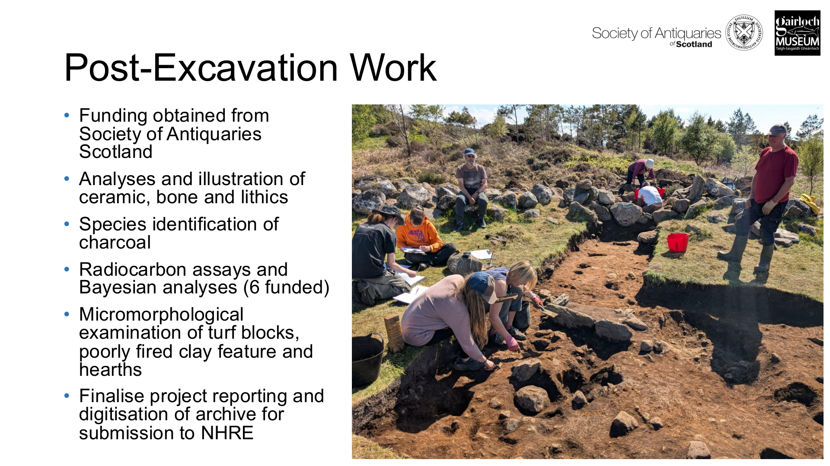
Figure 13. Post-excavation programme listed in the presentation. Source: Gardner presentation, slide 34.

Appendix: source list
- Dr Tom Gardner, Museum Talk: Achtercairn Roundhouse Excavation Findings, Gairloch Museum / HAF presentation, 4 May 2026
- Candy Hatherley and Ross Murray, Culduthel: An Iron Age Craftworking Centre in North-East Scotland, Society of Antiquaries of Scotland, 2021.
- Anne Crone and Graeme Cavers, Black Loch of Myrton: The life and times of an Iron Age wetland settlement in southwest Scotland, Sidestone Press, 2026.

