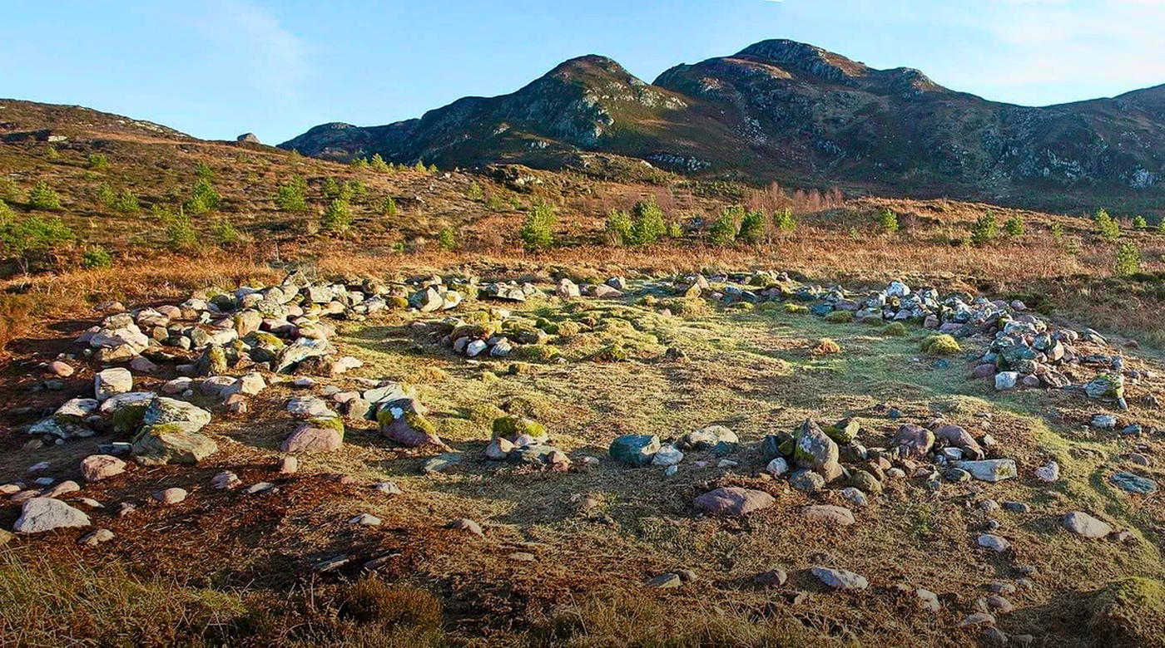
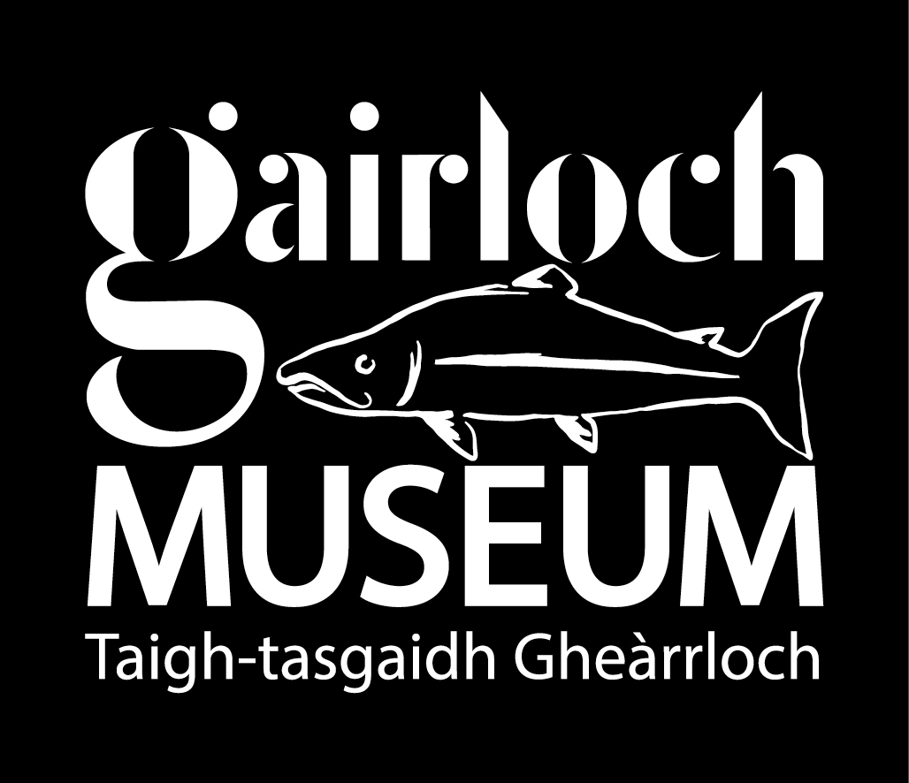

Gairloch Museum Roundhouse Project
Invitation to Tender: Traditional Craftspeople
Stage 1 design input and conditional Stage 2 build, training and engagement role
Issued by | Gairloch and District Heritage Company Ltd, Gairloch Museum
Project | The Gairloch Museum Roundhouse
Location | Gairloch Museum Outdoor Museum, Achtercairn, Gairloch, IV21 2BH
Planning reference | Highland Council planning reference 25/03362/FUL
Site reference | Outdoor Museum site at approximately NG 80349 76605
Tender return deadline | 28 July 2026
Contact | Corinna Annetts, Curator, curator@gairlochmuseum.org 01445 712287

1. Invitation and tender packages
Gairloch Museum invites tenders from specialist craftspeople for the Roundhouse Project. We are seeking craftspeople with practical experience in traditional building skills, heritage reconstruction or related craft practice, and the ability to work with volunteers, trainees, school groups and visitors. Tenderers may apply for one or more packages.

Package | Craft area
A | Drystone / stonework
B | Turf construction
C | Timber frame / greenwood joinery
D | Heather thatching
E | Internal floor (Stage 1)

2. Project background and design assumptions
Gairloch Museum is developing a full-scale reconstructed Iron Age roundhouse within its Outdoor Museum. The project is informed by the Achtercairn roundhouses behind the Museum and by community archaeology undertaken over several years (see Archaeological Note).

The Roundhouse project is both an archaeological reconstruction and a live learning build. The design must be informed by the Achtercairn evidence, while also allowing people to understand how that evidence is translated into a real structure. Craftspeople will play a key role in building the roundhouse and making the process visible and accessible. Safe opportunities for volunteers, schools and visitors to observe, learn and take part should be built into each craft phase. Gairloch Museum is keen for the Roundhouse Build to support local skills, employment, materials knowledge and long-term maintenance capacity.

The Team
The Roundhouse build team will bring together Gairloch Museum’s project staff, a dedicated Project Manager, Education and Engagement Officer, Film-maker, Evaluation Contract, ARC Architects and Narro Associates, with archaeological input from Dr Tom Gardner and Dr Tanja Romankiewicz from the University of Edinburgh. Craftspeople will lead the main construction phases - stonework/drystone, turf, timber/greenwood joinery and heather thatching - supported by volunteers, a 3-month paid local school-leaver placement, and HES Craft Fellows at key stages where extra hands are needed. The wider team also includes the Museum’s Education and Interpretation Groups and Sabhal Mòr Ostaig for Gaelic terminology and storytelling.

Participation and volunteer tasks
Participation will be structured through formal training, supervised live-build involvement, public demonstration tasks and school projects. The Museum will run skills courses ahead of each main craft phase so that a small number of trained participants can support the live build in a more involved role. Wider public participation will take place through safe tasks on weekly demonstration days during the build. Schools will contribute through full-day site visits and, where suitable, small classroom projects. Volunteers will be involved before the build through materials work parties, including heather picking, hazel coppicing/preparation and local stone gathering. Craftspeople are asked to identify safe tasks, supervision limits, tools/PPE requirements and the best timing for each activity, so that the Museum can advertise a public participation programme and organise work parties around the build timetable.

Design Assumptions (See Design and Access Statement)
For pricing, tenderers should assume the following; this is not a final construction specification:
- The proposed site is rough, semi-natural grassland immediately beside the existing Outdoor Museum, opposite Gairloch Museum, at NG 80349 76605. The ground slopes gradually from east to west, and the proposed development area is approximately 80m².
- The roundhouse is proposed as a circular plan approximately 8.3m in diameter.
- The walls are described as low walls with a local drystone rubble base, supporting an upper layer of turf walling.
- The building will have a single lockable timber entrance doorway.
- The roof structure will be a round-pole structure, using appropriate timber species.
- The roof will be conical heather thatch, rising to approximately 5.6m high.
- Timber joints are to be pegged or bound with ropes.
- The ground preparation is to mirror Roundhouse 10, with a shallow cut-and-fill to accommodate the natural slope.
- A land drain around the perimeter is proposed to keep the ground dry and take rainwater away from the walls to a local soakaway.
- The construction is intended to use no concrete and no metal materials, relying on natural materials only.
- There will be no mains electricity or water services.

- Access will be through an extension of the existing Outdoor Museum footpaths.
- The surrounding landscape is to remain semi-natural, with no enclosure fence around the roundhouse.
- Tenderers should allow for a construction approach that is largely manual, and based on biodegradable natural materials.

3. Procurement route and pricing
This is a two-stage procurement. Stage 1 will appoint craftspeople to provide paid design-stage advice. Stage 2, for Packages A-D, is a conditional build, training and engagement role. Stage 2 will proceed only if the building warrant is approved, and final prices are reviewed and agreed.
Package E is Stage 1 only. Later internal floor construction will be separately scoped and awarded through the interpretation/interior fit-out phase.

4. Stage 1 required outputs
- Attend a two-day in-person design and planning meeting in Gairloch in late August / early September, with the Museum, ARC Architects, Dr Tanja Romankiewicz and Dr Tom Gardner, and other appointed craftspeople, including:
  - a morning public session
  - meeting with the Museum Education Group to discuss safe, meaningful tasks for schools, nurseries, volunteers, trainees and public participation
  - design workshop to review construction options and delivery programme
  - visit to local material-sourcing sites to assess suitability of materials for heather, turf and hazel sites. (Stone and timber done separately).
- Provide a note after the Gairloch meeting, summarising recommended materials, method, sequencing, key risks, volunteer/school tasks, tools/PPE needs, and any unresolved design or warrant questions.
- Provide indicative cost, proposed access & storage requirements, and accommodation plan.
- Attend a half-day online review meeting in mid/late September to comment on the developing building warrant submission and help respond to follow-up questions from the architect, engineer or Museum.
- Provide follow-up comments where needed.

5. Stage 2 scope for Packages A-D
The Stage 2 role is expected to include the following, where relevant to the craft package:
- finalise the craft method statement with the project team;
- lead on materials sourcing, assessment, preparation, transport and storage;
- deliver the relevant craft package during the live build;
- supervise agreed volunteer, HES Craft Fellow cohort and school-leaver placement tasks;
- deliver 2 adult traditional skills course days for up to 8 participants, (4 days for Package A);
- deliver 5 school/nursery live-build learning days, planned with the Museum’s education team;
- deliver 3 x 2-hour sessions with the High School’s S1 SMART (Self-reliant, Mature, Active, Resilient, Teamwork) group;
- Identify safe volunteer and school tasks;
- support agreed public engagement, including visitor-facing explanation;
- support documentation of the build through notes, photographs, interviews and filmed explanation;
- provide craft-specific maintenance information and lead a training session for Roundhouse maintenance volunteers.

6. Package-specific requirements

Package A: Drystone / stonework
- Build the drystone base for the roundhouse walls, forming the lower wall structure that supports the turf walling above.
- Work with the architect, engineer and archaeologists to agree the wall profile, stone sizing, facing/packing/coping approach, and relationship between the stone base, turf walling, timber entrance.
- Use local, field-cleared or croft-sourced stone where practical, as well as quarry stone.
- Allow for community stone-contribution, including guidance on what types and sizes of stone can be accepted from local crofts.
- Grade and store stone close to the working area.
- Build the central hearth/fire setting.

Package B: Turf construction
- Construct the upper turf walling.
- Advise on turf specification, including likely turf depth, dimensions, cutting method, handling, stacking, storage, timing before use.
- Respond to the Achtercairn/Roundhouse 10 evidence, where stone tumble protected the turf wall top, and help determine how the reconstructed turf wall or cap should be built.
- Work closely with the stonework and timber craftspeople to resolve the meeting of turf walling, timber supports, entrance construction and thatch/eaves.
- Support assessment of local turf sources, including permissions, environmental impact, reinstatement and transport.

Package C: Timber frame / greenwood joinery
- Develop and build the round-pole structural frame for the roof.
- The timber structure should respond to the archaeological evidence for post/stake holes.
- Price for timber sourcing, transport, storage, preparation, and assembly on site.
- Include pegged and/or bound joints, using oak pegs, hazel, rope or braided plant-fibre bindings.
- Include the timber entrance doorway and split-timber pegged door construction.
- Work with the architect and structural engineer so the frame can be justified for building warrant and assembled safely on a restricted, public-facing site.

Package D: Heather thatching
- Deliver the conical heather-thatched roof, currently assumed at approximately 45-degree pitch and rising to about 5.6m.
- Advise on heather quality, quantity, picking/cutting method, bundling, transport, storage, and timing.
- Lead the heather pick with volunteers.
- Advise on hazel requirements for rods, rings, fixings, staples.

Package E: Internal floor advisory input only
- Advise on how the floor might respond to the archaeological evidence for a central hearth in an earth floor and possible organic “carpet” of plants, while also meeting requirements for public use.
- Consider floor build-up, levels, drainage/damp, wear from school and visitor use.
- Identify anything that must be fixed at building warrant stage, including fire safety, access.

7. Current programme for pricing
Dates are current working assumptions for pricing and availability checks. They may change as design, building warrant and material sourcing develop. Tenderers should state availability and constraints.
Timing | Main milestone
Summer 2026 | Stage 1 craft appointments and design-stage input.
August 2026 | Architect-led design development; craft input into buildability, materials, sequencing, quantities and warrant information.
Late August / early September 2026 | Public archaeology/reconstruction design workshop and site meeting
September-October 2026 | Building warrant package preparation and submission target.
December 2026 | Building Warrant approval target
January 2027 | Stage 2 awards subject to warrant, and prices; detailed course/workshop planning.
By 30 April 2027 | Material permissions and logistics: turf source, timber delivery, stone/test wall, thatching and storage.
May-June 2027 | Groundworks, welfare/site set-up.
July 2027 | Drystone/stonework phase, subject to final sequence (if wall is non-load bearing, it will be built after the timber phase).
August 2027 | Turf phase and timber/greenwood preparation.
September 2027 | Timber/joinery frame assembly.
October 2027 | Heather thatching;
November-December 2027 | External works, maintenance manual and handover information.
February 2028 | Current working opening/project completion point.

Tenderers should confirm their availability for the following possible two-day slots for the site meeting:
Possible Stage 1 meeting slot | Available / not available
Mon 31 Aug – Tue 1 Sept 2026
Mon 7 – Tue 8 Sept 2026
Tue 8 – Wed 9 Sept 2026
Wed 9 – Thu 10 Sept 2026
Thu 10 – Fri 11 Sept 2026

8. Site, safety, insurance and compliance
- The site is within the Museum’s Outdoor Museum. It is restricted, visitor-facing and may remain partly open during works. Large volunteer numbers cannot be accommodated every day.
- Craftspeople must work within agreed site capacity, public access arrangements, CDM requirements, safeguarding procedures and Museum risk assessments.
- Stage 2 will require suitable risk assessments, method statements, insurance evidence and site induction. PVG checks will be required where work involves children or young people.
- Tenderers should confirm current or proposed public liability, employer’s liability where applicable, and professional indemnity where applicable.
- Traditional materials may need long lead-in times. Tenderers should identify critical sourcing dates, storage needs and weather/material risks.
- The Museum must be able to use project documentation for education, maintenance, reporting, interpretation, social media and public access. Tenderers will be asked to grant Gairloch Museum a perpetual, royalty-free licence to use commissioned written notes, method statements, diagrams, photographs or similar project material.
- Craftspeople will be asked to take part in short filmed interviews, time-lapse documentation, photography and/or audio recording. The Museum will manage consent and crediting; tenderers should identify any restrictions.

9. Tender response requirements
Please submit the following information:
- Relevant CVs or short biographies for the lead craftsperson and proposed assistants.
- Examples of similar traditional building, or heritage reconstruction (if not contained in CV).
- Examples of training, public engagement or school/volunteer work (if not contained in CV).
- Completed pricing schedule.
- Availability for design input and the 2027 build period.
- Insurance details or proposed insurance arrangements.
- Health and safety approach, including management of volunteers, trainees, school groups and public interface.
- Conflict-of-interest declaration.

10. Pricing schedule
Complete the relevant lines for each package tendered for. Add rows if needed. State clearly whether figures include or exclude VAT.
Pricing line | Scope to price | Price type | Tenderer price / assumptions
Stage 1 design input | 3 days covering preparation/evidence review, 2-day design workshop, short technical note, drawing/specification review and follow-up. | Fixed price
2-day site visit | Travel, accommodation | Fixed price / mileage
Stage 2 build delivery (labour) | Packages A-D: estimated days, team structure. Package E: no construction price requested. | Day rate
Stage 2 build delivery | Travel, accommodation and expenses. | Fixed price / mileage
Material sourcing/preparation (labour) | Gathering and storage, estimated days. | Fixed price
Material sourcing/preparation | Travel, accommodation and expenses. | Fixed price / mileage
Build materials | Material supply for build based on building warrant quantities. | n/a | n/a – provide for stage 2 pricing.
Hearth/fire setting (labour) | Package A only, estimated days. | Fixed price
Pre-build skills training course | 2 full days per craft, up to 8 participants; 4 full days for Package A. | Fixed price
School/nursery live-build sessions | 5 full-day sessions per craft, planned with Museum education team.  3 2hr sessions per craft for the High School SMART group. | Fixed price
Materials | Tools, PPE and materials for training courses, schools sessions and weekly demonstration sessions during build. What tenderer provides; what Museum provides; hire/buy assumptions. | Fixed price
Maintenance manual, handover and documentation | 1-day maintenance volunteer training  Build report including methods, references and media. | Fixed price

11. Evaluation
Conflict-of-interest declarations will be reviewed before assessment or appointment.
Criterion | Weighting | What the Museum will look for
Relevant craft, traditional building and heritage reconstruction experience | 35% | Comparable craft delivery, traditional materials, building structures.
Volunteers, schools, public engagement and knowledge-sharing | 30% | Approach to skills training, school/live-build days, safe volunteer tasks, public explanation and inclusive learning.
Programme, capacity, health and safety | 15% | Availability, realistic team structure, health and safety competence, safeguarding awareness.
Sustainability and local benefit | 10% | Approach to local/regional material sourcing, low-impact transport, use of local subcontractors where appropriate.
Price and value for money | 10% | Clear pricing, assumptions, exclusions and day rates.

12. Documents supplied with this tender pack
- Design and Access Statement
- Archaeological note

With thanks to our project funders
 | 
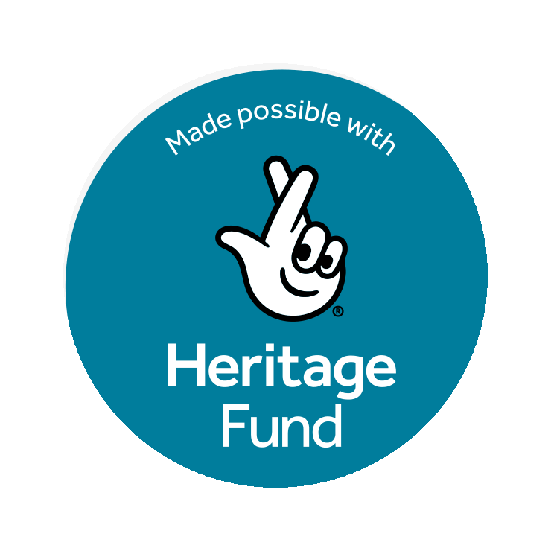 |   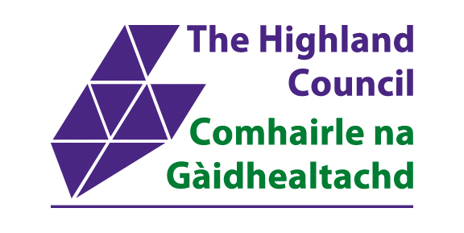

Supported by Historic Environment Scotland, Museums Galleries Scotland Museum Futures Innovation Fund, The National Lottery Heritage Fund thanks to National Lottery players, and funding from the Scottish Government, administered by The Highland Council Community Regeneration Fund.

