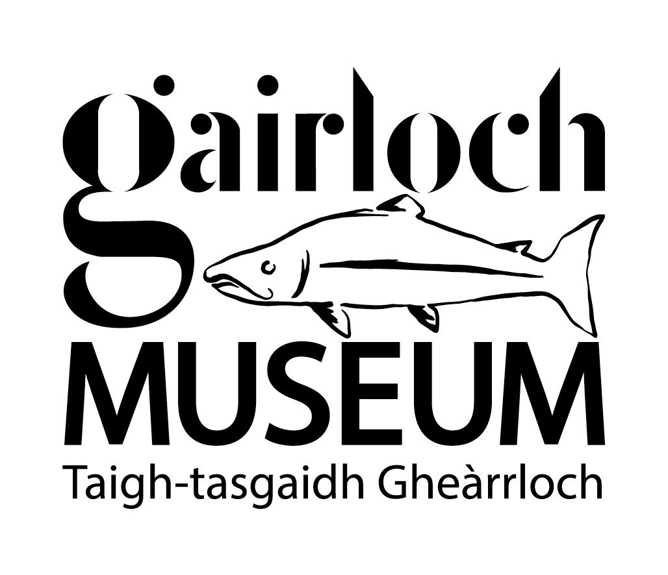

Accessibility Guide for Gairloch Museum
info@gairlochmuseum.org, 01445 712 287, https://www.gairlochmuseum.org/museum
Contact for accessibility enquiries: Eilidh Smith
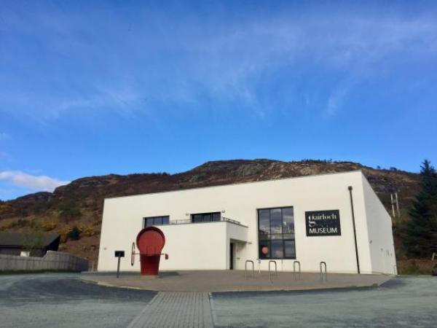

Welcome
Gairloch Museum is located in a converted nuclear bunker with galleries showcasing the history, culture and natural heritage of this beautiful area of the North West Highlands. Displays include the original lens from Rubh Re lighthouse, a replica croft house showing how people used to live and an interactive gallery about our magnificent natural world, midges and all!

At a Glance

Level Access
- There is level access from the main entrance to:
  - Dining Table
  - Ground floor galleries
  - First floor galleries
  - Welcome desk
  - Public toilet
  - Museum Shop
  - Outdoor Museum
- There is level access from the car park to:
  - Achtercairn Archaeology Trail Picnic Area

Hearing
- Some staff have disability awareness training.

Visual
- Glass doors have contrast markings.
- We have display information in audio.

General
- We have a complimentary ticket policy for personal assistants.
- There is at least 1 public toilet for disabled visitors.
- Some staff have disability awareness training.

Getting here
Gairloch Museum
Gairloch
IV21 2BH

Travel by taxi
- You can get a taxi with Hy Jack Taxi by calling 01445 712452.

Parking
- We have a car park. There are accessible parking spaces. The parking is less than 50 metres from the main entrance. Parking is free.
- The nearest drop-off point is in the carpark, 6 metres from the entrance. From the car park to the entrance, there is level access. The path is sloped.
- The route is 1900mm wide, or more.
- The main carprak is immediately adjacent to the Museum.
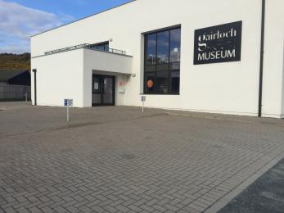
Photo showing main entrance to the museum and accessible parking spaces.
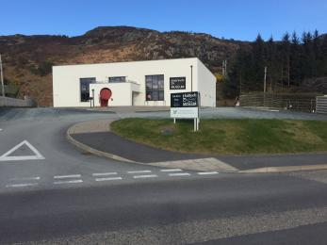
Photo showing main road and accessible pavement to Museum entrance.
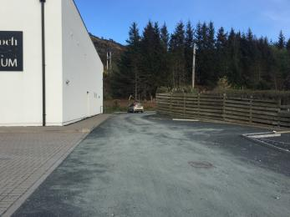
Photo showing additional parking spaces to the side and rear of the Museum.

Arrival

Path to main entrance
- From the street to the main entrance, there is level access.
- The path is 1900mm wide, or more.
- The path is sloped.

Main entrance
- The main entrance has level access.
- The door is 1700mm wide.
- The main door is side hung and manual.
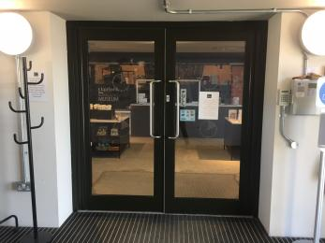
Inner doors to the Museum.
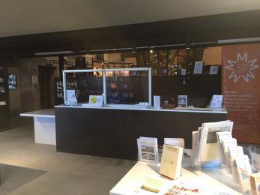
Welcome desk at the Museum.
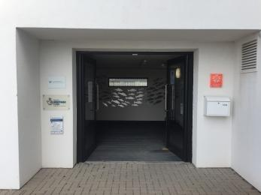
Exterior doors at the Museum.

Getting around inside

Visual Impairment - General Information
- We have contrast markings on all glass doors.

Lift
- We have 1 lift.
- You can get a lift to all floors.

Lift to all floors
- The lift is a platform lift.
- The lift door is 900mm wide.
- The lift is 900mm wide. The lift is 1450mm deep.
- The lift buttons have raised numbers or letters.
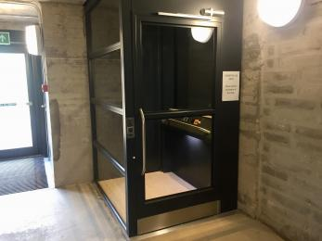
Lift to access all floors.

Ticket/ information desk

Welcome desk
- From the main entrance to the desk, there is level access. The route is 1350mm wide, or more.
- The desk has a low section.
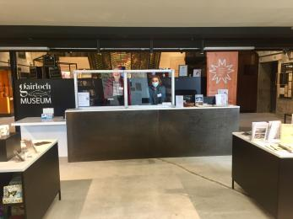
Welcome desk.

Things to See and Do
- We have a complimentary ticket policy for personal assistants.
- We have display information in: audio.

Ground floor galleries
- From the main entrance to this area, there is level access. The route is 1350mm wide, or more. Some display information is low, for wheelchair users. There are seats.
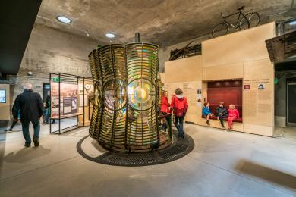
Ground floor gallery.

First floor galleries
- From the main entrance to this area, there is level access. There is a lift.
- From the lift to this area, the route is 900mm wide, or more. The door is 900mm wide.
- Some display information is low, for wheelchair users. There are seats.
- Videos have subtitles.
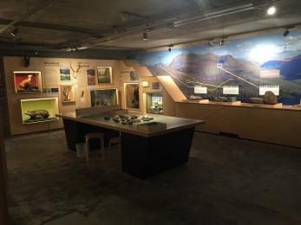
Upper floor, natural history gallery.
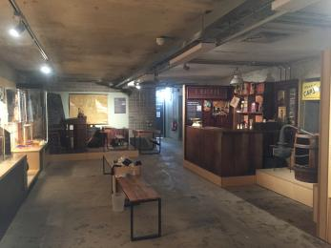
Upper floor, walk through time gallery.

Public toilet

Public toilet
- There is a public toilet for disabled visitors.
- From the main entrance to the public toilet, there is level access. There is a lift.
- From the lift to the public toilet, the route is 850mm wide, or more.
- The toilet door is 850mm wide.
- The direction of transfer onto the toilet is to the left.
- There is 1000mm at the side of the toilet. There is 1500mm in front of the toilet. The toilet seat is 500mm high. The toilets have handrails.
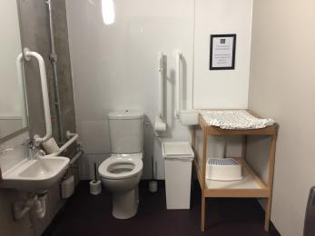
Photo showing disabled access toilet. Items to the lefthand side of the toilet can easily be moved by Museum staff.

Shop

Museum Shop
- From the main entrance to the shop, there is level access. The route is 1400mm wide, or more. The route through the shop is 800mm wide, or more.
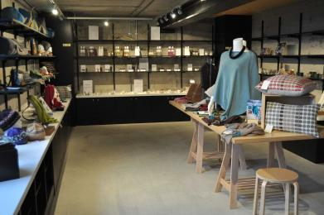
Museum shop.

Place to eat and drink

Am Bàrd
- From the main entrance to the dining area, there is level access. There is a lift. From the lift to dining area, the route is 900mm wide, or more. The door is 900mm wide.
- To get to a table, there are no steps.
- The route through the dining area is 800mm wide, or more.
- There is no background music.
- We cater for vegetarian, gluten free (celiacs), lactose free (dairy free), nut free and vegan specific diets.
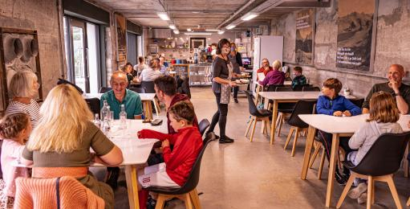
Am Bàrd Cafe.
- From the main entrance to this area, there is level access. There is a lift.

Getting around outside

Designated Walking Trail

Achtercairn Archaeology Trail
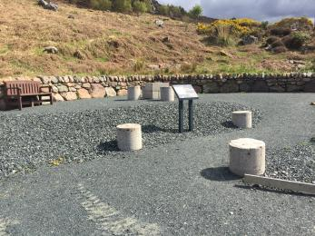
Start of the Achtercairn Archaeology Trail with seating and even surfaced path.
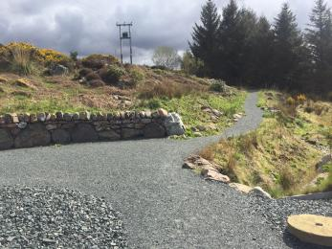
First section of the Achtercairn Archaeology Trail with slightly sloping path.
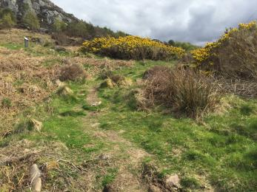
Hill track that forms the remainder of the Achtercairn Archaeology Trail.
- The trail is 3200metres long. Some of the trail has a loose surface. The first section of the trail, around 20 metres is hard and even, but gently sloping. From then on the trail is a narrow hill path with an uneven surface . The trail is sloped. The trail has seats.

Picnic Area

Achtercairn Archaeology Trail Picnic Area
- From the car park to the picnic area, there is level access. The path is 1200mm wide, or more.
- The entrance is 1200mm wide.
- You can bring your own food to the picnic area.
Picnic area at the start of the Achtercairn Archaeology Trail.

Outdoor Museum
- From the main entrance to this area, there is level access. There is a permanent ramp. The route is 1300mm wide, or more. The entrance is 1300mm wide.
- The Outdoor Museum is an area over the main road, in front of the Museum where some large Museum objects are located as well as interpretation panels about the local Geology and Fishing Economy. There is a hard, even surfaced path running through this area which is 1100mm wide at its narrowest point.
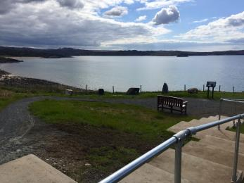
Pathway and stair to Outdoor Museum.

Customer care support

Accessibility equipment
- For a list of more items, please go to https://www.gams.org.uk.
- There is an area in front of the Museum over the road where dogs can be exercised. We kindly request removal of any dog waste.
- We have an area to charge mobility scooters and battery powered wheelchairs.
- Mobility Scooters and Battery Powered Wheelchairs can be charged in the lobby of the Museum, in sight of the staffed Welcome Desk.
- You can hire mobility equipment from Gairloch Aid and Mobility Support by calling 01445 741 274.

Emergency evacuation procedures
- We have emergency evacuation procedures for disabled visitors.

Customer care support
- Some staff have disability awareness training.

Guide last updated: 28 April 2022

